**DAILY ASSESSMENT FORMAT**

|  |  |  |  |
| --- | --- | --- | --- |
| **Date:** | **21/05/2020** | **Name:** | **Shilpa S** |
| **Course:** | **TCS ION** | **USN:** | **4AL14EC078** |
| **Topic:** | **Learn Corporate Telephone**  **Etiquette**  **Understand Accounting**  **Fundamentals**  **Gain Foundational Skills in IT** | **Semester & Section:** | **8th - Asec** |
| **Github Repository:** | **Shilpa-online** |  |  |

|  |
| --- |
| **FORENOON SESSION DETAILS** |
| **Image of session**  **C:\Users\muddhu\OneDrive\Pictures\Screenshots\Screenshot (870).png** |

**Report –**

**Learn Corporate Telephone Etiquette**

In this online course on Learn Corporate Telephone Etiquette I learn that what we say, how much we say and how we say plays an important role in the impression we create on the listener. Through this module I learn important guidelines to be followed for effective corporate telephonic communication.

Throughout this course I learned following things –

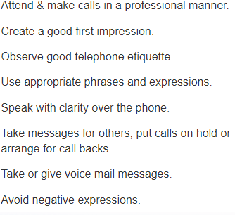

**Do’s of Telephone Etiquette**

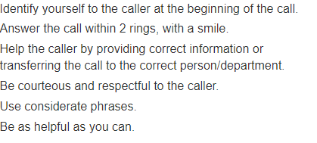

**Don’ts of Telephone Etiquette**

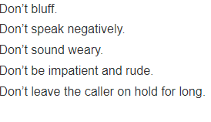

**Telephone Courtesies**

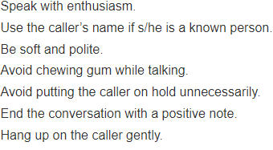

**Understand Accounting Fundamentals**

**Basics of Accounting –**

Accounting is the practice of recording and reporting on [business transactions](https://www.accountingtools.com/articles/2017/11/30/business-transaction).

System of record keeping - First, there must be a rational approach to record keeping. This means setting up [accounts](https://www.accountingtools.com/articles/2017/5/7/accounts) in which information is stored. Accounts fall into the following classifications:

* Assets - These are items purchased or acquired, but not immediately consumed. Examples are [accounts receivable](https://www.accountingtools.com/articles/2017/5/7/accounts-receivable) and [inventory](https://www.accountingtools.com/articles/2017/5/13/inventory).
* Liabilities - These are obligations of the business, to be paid at a later date. Examples are [accounts payable](https://www.accountingtools.com/articles/2017/5/5/accounts-payable) and [loans payable](https://www.accountingtools.com/articles/2017/5/9/loan-payable).
* Equity- This is assets minus liabilities, and represents the ownership interest of the owners of the business.
* Revenue- This is the amount billed to customers in exchange for the delivery of goods or provision of services.
* Expenses- This is the amount of assets consumed during the measurement period. Examples are rent expense and wages expense.

**Gain Foundational Skills in IT**

Foundational skills are the fundamental, portable skills that are essential to conveying and receiving information that is critical to training and workplace success. These skills are fundamental in that they serve as a basis - the foundation for supporting additional operations/tasks and learning. Reading a manual, listening to instructions, writing a memo, and working well in a team are all examples of using foundational skills on the job. Foundational skills are important across a wide variety of jobs, both skilled and professional. They are also necessary to learn more job-specific knowledge and skills. This is true across a wide variety of skilled and professional jobs.

The bottom line is that the importance of foundational skills will only increase. Educators and employers must work together to ensure that workers are prepared for the jobs of today and tomorrow that will keep our nation competitive in the global marketplace.